This is for Someone I Loved

“Goodbye, Lois, and I forgive you for everything I did to you.”
-Robert Penn Warren, All the King’s Men

Your sister doesn’t think you killed yourself. She came to my parent’s house the day after your funeral, where I was staying for the weekend, and asked what I thought about the pastor’s eulogy. I said I thought it was nice.
The pastor didn’t know you, she said. In fact he’d never met you, and she didn’t like that. Being your twin, of course, she knew you better than anyone. She said she hated how the pastor made it sound like you killed yourself.
She told me that the police found you at your desk with an open Mountain Dew and a box of Oreos like it explained everything away. I laughed with her anyways; it was just like you.
Your sister confirmed the things that had been masquerading as rumors since your death: that you hadn’t spoken to anyone in your family for nearly two weeks. That there was a car wreck you’d somehow walked away from a few days before they found you dead. That you’d run the car so hard into a tree the engine was found in the dirt several feet away. That no one was really sure, but you died sometime between Thursday night and Saturday morning.
That there was no note. This, overall, your sister believes absolves any suspicion of suicide.
“He would have been the person to write a long fucking letter,” she said, “you know it.” And I did know it. I used to keep those letters from you; I knew it very well.
“Do you have any questions?” your sister asked when we’d been quiet for too long. I was sitting at the kitchen table with my legs drawn up to my chest. She was defensive against something, and I didn’t know what else to ask.
“He didn’t kill himself, then?”
“No,” she said, “he didn’t.”
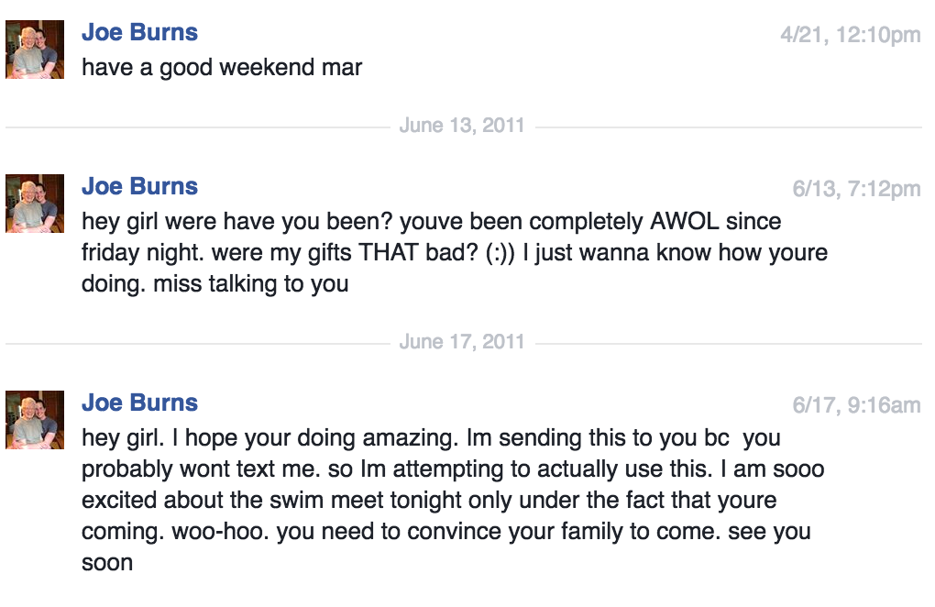

A few weeks after you died I had a dream I was sitting at an office desk somewhere. My mother called and said they’d found a note in your car that read “YOU WERE RIGHT” in handwriting that looked like scars. Definitely yours.
I hung up on her. Goddamn, it was just like you to say something like that, to pull guilt out like sore teeth from your deathbed or desk chair or wherever you were. When I woke up everything angry had returned. I stared into stale coffee all day, looking for more signs.
Here is the honest truth: I do not know how to talk about you. I cannot put together words that explain how much I loved you and how much I hated you. I cannot dredge up enough memories to show how much you broke me, how much you made me. Recent boys who learn my story have asked if I’m still hung up on you, and I always feel like Quentin trying to tell Shreve about that complicated and unavoidable thing, the thing that he will always be, except the last words to my masterpiece have always been the exact opposite of his: “I don’t love him, I don’t love him, I DON’T!”
I will say it plainly: you abused me. You manipulated my emotions and you played my guilt, you controlled my actions and you drove my voice so far away that it took me five years and a shit-ton of whiskey to find it. The therapists I’ve seen have diagnosed you with narcissistic or borderline personality disorder, and even once as a psychopath.
But therapists have also told me I’ll never be close to God as long as I’m still anorexic, and where the hell do they get off with that? They don’t know God. They don’t know you.
These are the things I have left from you: two antique devotionals, a “Britain’s Best Friend” coaster, and the green ink pen you stole from the gym monitor. That is everything in my possession, and they’ve remained for functionality rather than for sentimental reasons.
At some point in the summer when I was most ill (hair falling out arbitrarily and bones looking like they’d rip open my skin) I threw away everything else you’d ever given me. It was an exhausting process, diving through boxes shoved under my bed and sometimes shuddering when I pulled out an object. All those old feelings still lived in them: your smiling face and my insides doing something that felt like cannibalism.
After you died I tried to find anything I’d missed, any scrap of wrapping paper or a card with your handwriting, but I’d been very thorough in my bridge-burning. The only things I could find were pictures of friends where you sometimes appeared. You were the best friend and the abuser and the love and the fear and the great thing that once controlled my life. When you died I was frantic with the loss of everything.
There was no physical remnant of you to reclaim; I’d ripped you up and burned you down and taken you out in big black trash-bags slung over my little skeleton. I even threw away the pictures of me you’d stuck in my mailbox after ripping them off your wall, the last of your efforts to guilt me back. It was all gone, nothing was left to remind me that you’d once been everything I was afraid of, not even you.
You are gone, and then sometimes I see your shadow on the wall or your face on someone’s body and I can’t move.
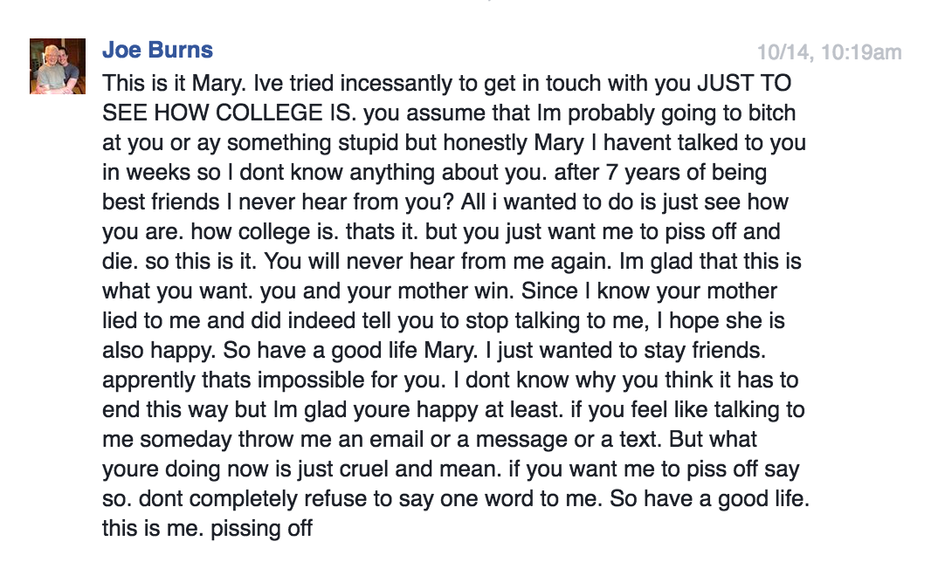
At thirteen, you declared yourself my protector. In any restaurant, you sat at the perfect place to observe all possible threats. On a Sunday afternoon after church, you outlined to our mothers the danger that other boys in our school posed to my innocence. In the bleachers at a basketball game, you ripped the headphones out of my ears to keep me from hearing something you deemed offensive to my innocence. Wherever I existed, you existed to ensure my safety, and out of that debt I belonged to you, by everyone’s standards.
When you told me you loved me for the first time, I felt that I had done something wrong. Too many smiles, to many conversations, too much getting along in general. I had let it go too far, I thought, and so I had to be nice about it. But the problem was that I did not love you back, or at least not in the way that you wanted.
Maybe I just said that a romantic relationship was a bad idea, that we were too young, or that I wasn’t ready. I told you that I loved you like a brother and then you were upset, so the night after your confession when we went to Wendy’s I did not stop your arm making its way around my waist. The guilt began to build.
When we were 18 and college freshmen hundreds of miles apart, I was not ignoring you. I was hiding. I was waiting for the fight to blow over and I was trying to keep my mother together from so far away. I was trying to pretend like I was okay, like everything was normal, like we were all just moving on with our lives. But really, I was hiding because I was just beginning to realize that my life was not normal. I was not okay.

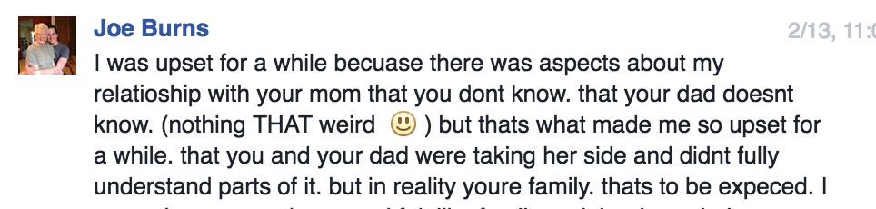

I do not know what you mean by this.
All I can remember is everything. All I can remember is falling asleep in a hotel bed with you and my mother. All I can remember is her giving you my father’s clothes to wear when we got caught in the rain. That she started taking pills after your last fight and that your absence turned her into a child prone to tantrums. All I can remember is that feeling in my gut, deep down and bilious.
It was obvious that she loved you, and I hated her for it. I hated you for breaking my family and I hated you both for whatever broken thing you had in common. I hated that you matched so perfectly.
The night before your funeral, my mother had to leave the restaurant where my family was eating because she just couldn’t quit crying. I ordered a shot of whiskey and my father gave me a disapproving look. He started on about how alcohol isn’t the way to deal with things but I was already drunk enough to tell him about the suicide phone-calls and the box of your dead father’s belongings under my bed. I’d never told him these things, and took the shot himself.
A few drinks later, my father told me that he’d taken my mother on a weekend vacation several years before to get the business of you off his chest. I did not know that she’d left his careful questions to answer a phone-call from you, or that he once drank a whole bottle of wine in the front yard because you’d disappeared somewhere with her, his wife. My father told me that he never got any apology and never received any explanation.
“There are things I just don’t need to know,” he said, and I understood.
When I was a child, long before I knew you, I found a journal in my mother’s bathroom drawer. I must have known even then that abortion was something I was not supposed to talk about because I held the paper out over the stairwell like it was some murder weapon I’d uncovered. My mother yelled at me from the bottom of the stairs, “There are things that you don’t know about me – Do you want to know them? Do you?”
I don’t know what you mean by that, either of you. I never want to know.
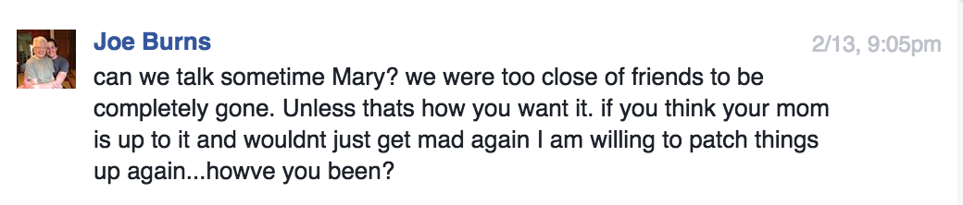

When you left I stopped eating, but that makes it sound too simple. When you left you broke my mother’s heart and I could not heal it. When you left there was no one to fight back against and there was no one controlling me. When you left I lost my identity and my self. When you left I got what I wanted: I was 600 miles gone, and irretrievably alone.
We had not spoken in three months when you sent me this message, the longest absence of you in my life for seven years. When you sent me this message, I was well on my way to nothingness. I was running every morning, eating one item of food at least twenty-four hours apart, and refusing all fluids. I was weighing myself without any clothing, any jewelry, or any breath. I was starving myself to death, and it felt good. When you left I was free to destroy what you’d made of me, and soon I was almost gone.

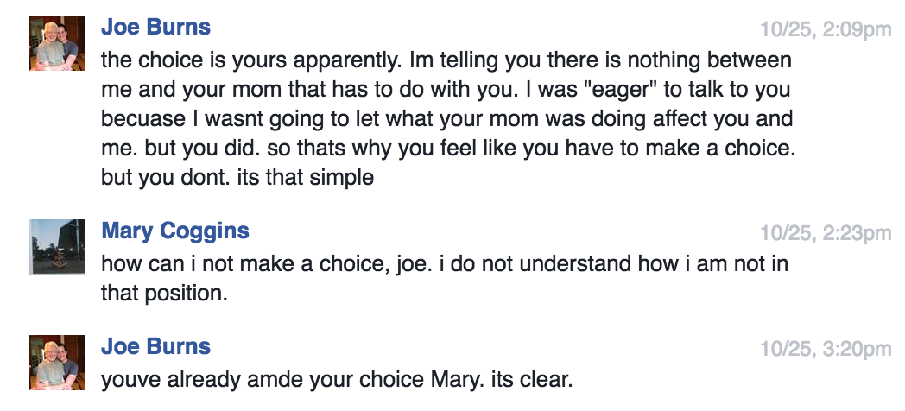

Two months into college you broke my mother’s heart and I stopped speaking to you. Eight months later I was almost dead from self-imposed starvation. Six months into my recovery you were diagnosed with stage four cancer.
The day I found out you were sick I sent you a message. It reads: “Hi. I’m so sorry you’re going through this. You don’t deserve it. Mary.” You never responded.
The next week I wrote you a letter that I carried around for a month until someone else mailed it for me. I wanted you to know that I was sorry, that I loved you, in some way at least. I wanted you to know before you died, although in the end it wasn’t the cancer that killed you. In the end we are so much like each other; we both destroyed ourselves.
I’ve asked almost everyone it would be appropriate to ask, and no one thinks you knew what happened to me. I’m grateful for that. How could I tell you ruined me? How could I explain that after every pound I dropped on the scale the guilt of you still weighed me down? What would you say if I told you I do this to myself because you made me believe I deserve it?
I almost killed myself because of you. Maybe that’s why I can’t help thinking that you killed yourself because of me.
The day of your funeral my sister said that I should not take it so personally. It was high school, anyways.
“There will be other people there he hurt,” she said, and I fought back against it.
“Not like me,” I said, “Nothing like me.”

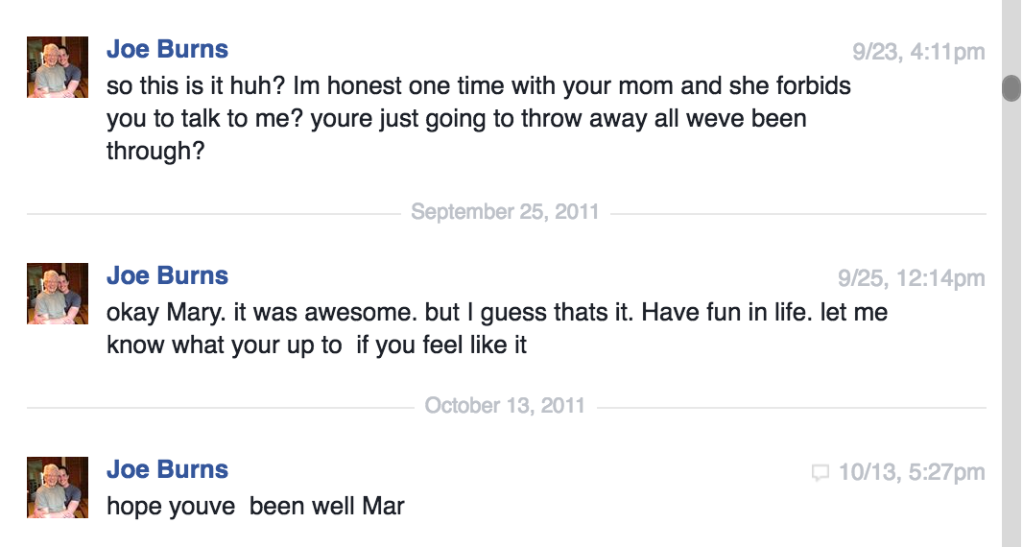

Most of our friends don’t know that you had a wall in your room filled with pictures of me. You can see it in a video of you lip-syncing on YouTube. I never gave the pictures to you, so you either printed them off yourself or got them from somewhere else. My mother might have gotten them for you.
You knew all of my family, my cousin and her high-school boyfriend, the uncle with the mullet, even my step-great-grandfather. You were at my house on the weekends and joined family vacations. You were in every extra-curricular with me and became interested in the colleges I liked. You were a fixture of my world and I wanted so badly to conceive of a self without you.
Most of our friends don’t know that you threatened suicide to me several times, both in person and over the phone, so that I would say I loved you. They don’t know that you gave me a box of your dead father’s belongings stolen from your mother’s closet, just to show how much you cared. They do not know about the roses you sent for Valentine’s Day or the jewelry you bought from Hawaii.
My mother called me selfish for not loving you, but you engulfed my life so completely that I don’t think there was a much of a self to be selfish for.
After history class one day in tenth grade our teacher asked me to stay for a minute. It was the end of the day and I was ready to go home, but he asked me to sit down.
“Something isn’t right here,” he said, “I don’t want to step on toes, but are you okay?”
“Everything’s fine,” I said, “We’re only friends.”

That was enough for our teacher to leave it alone. Perhaps I was afraid that if I told the truth someone would find out that I couldn’t handle it myself. Perhaps I was afraid what would happen to our community if the peace was disturbed. Mostly, I think, I was afraid that they all would find me as guilty as I felt.

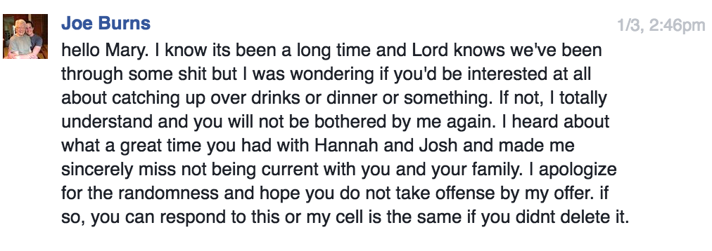

When you sent me this message I had deleted your number several times but I’d never blocked it. I told the therapist that I didn’t know how, but really I’d just hoped you would leave me alone. Whenever I recognized your number I was afraid.
By 2015 I had not seen you for four years. I’d seen a nutritionist and a therapist and you’d seen a radiologist and a surgeon. You sent an envelope of pictures with a message that said: To Mary, I don’t need them anymore. I put the shoebox of your father’s things in your mailbox and wrote: To Joe, they never belonged to me.
You totaled my car with a flowerpot from the backyard. I mailed you a long letter. We both lost our hair.
I used to have dreams that you would show up somehow at my apartment 600 miles away from home, screaming and slashing and making a scene about how I was supposed to love you, I’d said I loved you once, I’d talked about the stars.
I would have betrayed you, and you would be a martyr again.
No one could possibly save me from the guilt.

Feb 2 2016, 7:36 pm via SMS:
“I don’t have Nathan’s new number but I had to tell someone haha”

I have read our last conversation several times since you died. I had to look it up through my account history online because I’d deleted it from my phone. Our recorded correspondence via text does not go back farther than this message, although I would like to read what we said to each other before you got sick. Before I got sick.
I would like to remember before you killed yourself.
I was in class when you texted me, pretending to have read Samuel Richardson’s Clarissa. I’d made a personal exception on the grounds that the 800-page novel (abridged version, mind you) of a girl who starves herself to death after being forced into a relationship and subsequently raped would not benefit my mental health. It was too similar to my reality.
Seeing your name on my phone disoriented me, because we did not speak anymore. I did laugh at the message, though; after everything you could still make me laugh. We talked for a while– I was waiting to go out with a friend and had the time. You said you thought I hated you and I said I that did not.
No, I did not hate you. I do not remember ever really hating you. I was afraid of you and I missed you, I was angry with you and tired and sorry. I really did love you, just never in the way you needed.

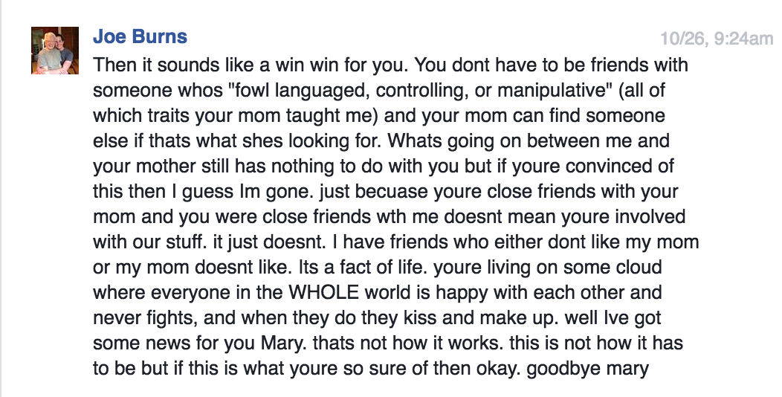

I’m still so goddamn angry. I’m angry at you for the manipulation and abuse and the time you spit in my face on the basketball court. I’m angry for the Gatorade and chewing gum you bought me every week and left in my room, I’m angry about the time you tried on my swimsuit, I’m angry about the time you were in my great-grandparent’s house, I’m angry that I fell asleep on your shoulder, I’m angry that I held your hand, I’m angry that I threw everything away except the pictures, every scrap of the gold wrapping paper with green holly, every piece of paper with your handwriting, every gift and memory is gone.
I’m so angry that you’re gone; you will always be the martyr now, and I hate you for it, I really hate you for it.
At your funeral, the pastor talked about the drinking. You were never a drinker when I knew you, but neither was I. The pastor slid the word ‘drinker’ in with a list of other things you were: brother, fighter, scholar, friend, athlete, lover. Lover of women, the pastor said, and I was terrified for a moment. But he spoke about your mother and your sisters, your grandmother and your girlfriends, and I was none of those. I was barely even a woman when you knew me. You were barely even a man. But somehow, you will last me a lifetime.

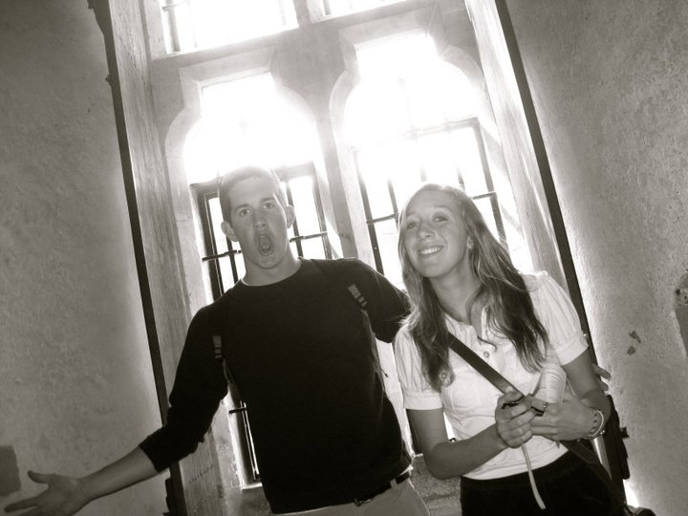

I was at work when our friend left a message on my phone to call him back. He doesn’t normally call without a heads up beforehand, so I figured something was wrong. I thought maybe his girlfriend had broken up with him, so I went into the utilities closet to call him back.
From what I remember, he didn’t use the word dead. He just said they’d found you. A few hours before, they’d found you. They weren’t sure if it was the cancer or if you’d killed yourself, but he’d call back with the funeral plans. He was crying.
I tried going back to frying donuts. The waiter I’d recently slept with kept coming over to flirt and I was working so hard on not breaking down at the foot of the deep-fryer. People were eating brunch and I remembered the last thing you’d said to me, to which I’d never responded: “I’m really glad to have you as a friend again.”
I left work and went directly to a bar, where I ordered a drink and a shot that took me two hours to consume. Some poor unsuspecting soul plopped himself down next to me and threw out a rusty hook: “So what brings you here today?”
It was the last day of the Cherry Blossom Festival in DC, so I guess he had every right to ask why I was in a poorly-lit dive bar at 3 in the afternoon, but once he asked I lost any togetherness I had.
“Do you wanna hear a story?” I asked through tears and snot. After ordering us both more shots, my bar-neighbor obliged, and I told him everything. To this day, I have never told our story so coherently and I laughed through most of it, as if it were all some ridiculous cosmic joke. My bar-friend hugged me frequently, and I worried that with every turn he would think I was making it all up. Seven-year-abusive-relationship-plus-mom-plus-anorexia-plus-cancer-plus-potential-suicide-that-happened-today just sounds a little contrived. But it wasn’t. It was my life, and you were dead.
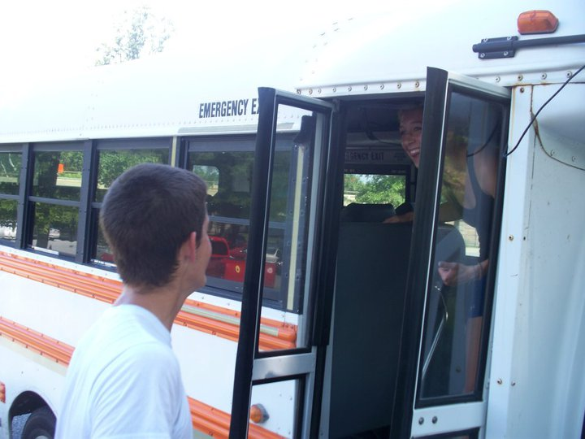

After you died I did not go back to my classes. I barely finished my final papers. I went to work and I drank and I slept. I went to your funeral and I packed two dresses because I wasn’t sure which one you’d like better. I was angry with the girl in the pew in front of me who, just before the service started, whispered to her friend “I don’t know if I can handle this.” Who the fuck are you, I thought. Who the fuck are you?
After you died I answered phone calls from our friends at 2 in the morning and I drank. I puked up sweet potato fries and had to be fireman-carried out of a bar. I read over our Facebook messages and I drank. I slept and I dreamed about you, I woke up and I realized I was still afraid so I ordered your favorite whiskey at bars and I cried. I sent emails to my professors explaining why I was not in class. They sent their condolences along with links to campus counseling services. I did not go.

Feb 2 2016, 8:12 pm via SMS:

“Had to take a semester, yes. Last semester was really hard for my and my family. Plus I was triple majoring so it’s nice to take a breather. But the PTSD and depression and anxiety are why I’m taking a break. It’s pathetic of me I guess.”

Here is what I think happened: You were drunk at some Norfolk bar very late at night and perhaps by yourself. The cancer hadn’t come back yet but it had already come back twice; what was stopping it now? You couldn’t play sports anymore because of all the surgeries around your chest from where the cancer had been the last time; you were still working on your undergrad degree because all of the treatment had prevented you from finishing on time. You were tired.
You were tired and drunk and decided to end it all by driving full-speed into a tree, but somehow it didn’t work. So you went home. You walked to your apartment or you got a taxi, but you never called anyone about the car. You were too upset about not being able to kill yourself. So you got home and maybe you took some pills or maybe you just sustained some kind of internal injuries from the wreck, but you died there, with a box of Oreos and a can of Mountain fucking Dew.
During the eulogy, the pastor who did not know you said that he was sure if you’d called any of us there at the service, we would have answered. But I don’t know about me. Would I have answered you? Would I have talked you out of suicide again? Would you have asked if I still loved you?
There was no autopsy performed on your body. The doctors said it would be inconclusive based on the amount of surgeries you’d received. Your sister does not think you killed yourself, but I think I do.
A few hours before I had to be dragged out of yet another bar, I typed in your number from memory into my phone. I was drunk and alone and a piece of glass on the ground outside had looked deliciously appealing. I sent you a message although you’d been dead for at least two weeks.

Perhaps someone read my message, or maybe your phone line had been disconnected already. I’m not sure what the process is for things like that. But I want you to know that I miss you and I’m tired and I’m so, so sorry that I could never be what you needed. I hope you are at peace, finally, wherever the hell you are. We were something once, after all.

